**ASSIGNMENT - 1**

**Problem-1**

**Create a Navigation bar using HTML (With out CSS and Bootstarp), it should contain**

**-> Home**

**-> Signup**

**-> Login**

**-> Search Bar.**

**Index.html**

<!DOCTYPE html>

<html lang="en">

<head>

    <meta charset="UTF-8">

    <meta name="viewport" content="width=device-width, initial-scale=1.0">

    <title>Navigation Bar</title>

</head>

<body>

    <nav>

        <a href="index.html">Home</a> |

        <a href="signup.html">Signup</a> |

        <a href="login.html">Login</a> |

        <input type="text" placeholder="Search..." />

        <button type="submit">Search</button>

    </nav>

</body>

</html>

**Output:**

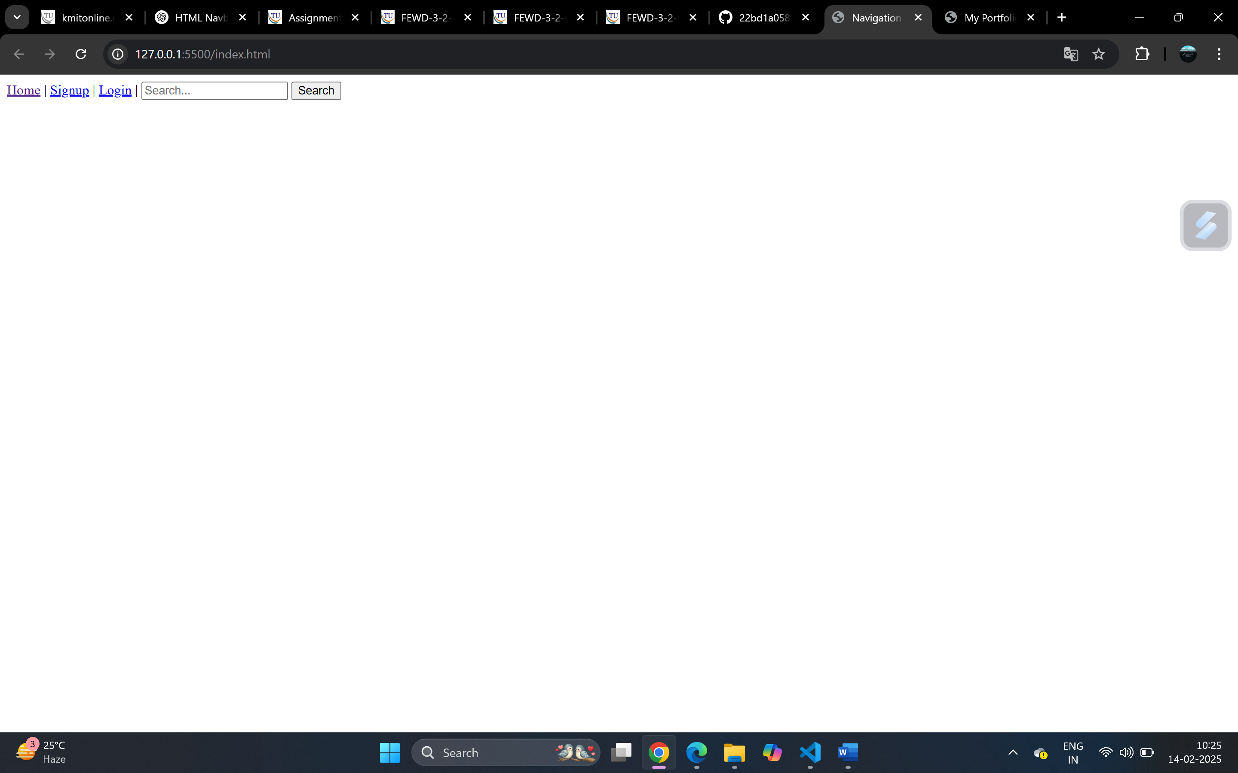

**Problem 2:**

**Create a Portfolio page using HTML , it should contain**

**-> Self introduction**

**-> skills**

**-> projects/work experiences (Git links)**

**-> Feedback /achievements**

**-> Education profile**

**-> Contact information.(Social media /phone /email)**

**Portfolio.html**

<!DOCTYPE html>

<html lang="en">

<head>

    <meta charset="UTF-8">

    <meta name="viewport" content="width=device-width, initial-scale=1.0">

    <title>My Portfolio</title>

</head>

<body>

    <h1>My Portfolio</h1>

    <h2>Self Introduction</h2>

    <p>Hello! I am Sadhika Prasanna, a passionate developer with experience in web development.</p>

    <h2>Skills</h2>

    <ul>

        <li>HTML, CSS, JavaScript</li>

        <li>React, Node.js</li>

        <li>MongoDB, MySQL</li>

    </ul>

    <h2>Projects / Work Experience</h2>

    <ul>

        <li><a href="https://github.com/sadhikaprasanna/MechAI-Chatbot">MechAI-A Virtual Car Mechanic Chatbot</a></li>

        <li><a href="https://github.com/sadhikaprasanna/prescription-qrcode-generation">Prescription QR-Generator</a></li>

    </ul>

    <h2>Feedback / Achievements</h2>

    <p>Received positive feedback from mentors and reviewers for efficient code and design.</p>

    <h2>Education Profile</h2>

    <p>Bachelor's in Computer Science, Keshav Memorial Institute of Technology</p>

    <h2>Contact Information</h2>

    <ul>

        <li>Email: saadhikaprasanna28@example.com</li>

        <li>Phone: +1234567890</li>

        <li>GitHub: <a href="https://github.com/sadhikaprasanna">Your GitHub</a></li>

    </ul>

</body>

</html>

**Output:**

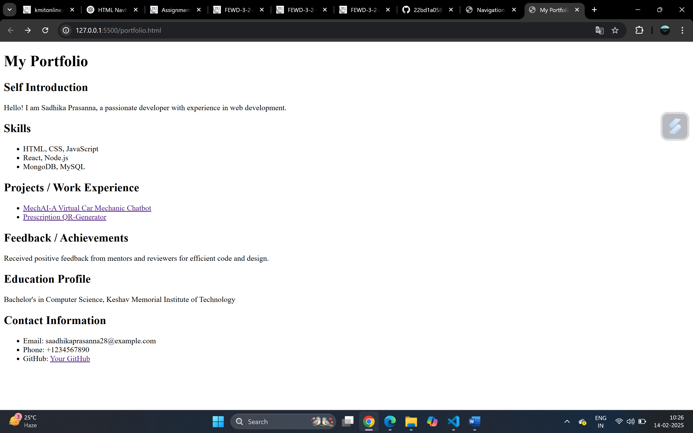

Github link : https://github.com/22bd1a058f/index-portfolio-with-html